This Isn’t the Antichrist You’re Looking For…Move Along: The Chaos and Confusion of Pop-Prophecy’s Mind Tricks
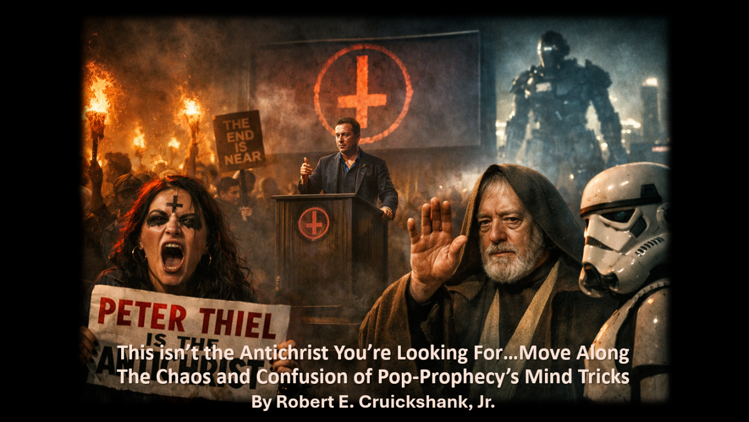
By Robert E. Cruickshank, Jr.
Copyright © Robert E. Cruickshank, Jr. (January 11, 2026)
Daniel E. Harden (Editor)
All Rights Reserved

“We’ve been looking for a messiah to bring in the end times,” said a woman who called herself “Satan’s Babygirl” and had a black upside-down cross painted on her forehead. “We believe Peter Thiel is the Antichrist we’re looking for.”
- Protestor at Peter Thiel’s Antichrist Lectures (San Francisco Bay Area)

You don’t need to see his identification. These aren’t the droids you’re looking for…Move along.
- Obi-Wan Kenobi (Star Wars: A New Hope)

The chaos and confusion in the first quotation above reveal the chaotic, confusing results of pop-prophecy’s version of the Antichrist. Not that the Bible’s own portrayal of the Antichrist is confusing. It’s not. Very simply, the Bible uses “antichrist” for first-century Jews who once professed Jesus as Messiah but later renounced that confession and returned to Judaism. This is the picture that emerges when we study the Bible’s four “antichrist” references in context (1 Jn. 2:18, 22–23; 4:7; 2 Jn. 7). When set alongside of the prophecy pundits’ Antichrist, the Biblical version simply doesn’t fit their narrative.
For this reason, the purveyors of pop-prophecy don’t spend much time dealing with these four verses when they’re discussing the Antichrist. When a preacher is going to address a particular topic, he’ll typically say, “Turn in your Bibles to ______________.” And the blank is filled in with passages that relate to the subject on which he’s going to be speaking. Not so, when it comes to the Antichrist. Hence, the reason for the second quotation above.

Turn in Your Bibles to… Anywhere But Here
Much like Obi-Wan Kenobi using a Jedi Mind Trick on the stormtroopers in Star Wars, the pundits’ message is: “You don’t need to see his Biblical identification. This isn’t the Antichrist you’re looking for. Move along.”
Then, just like Obi-Wan sneaking C-3PO and R2-D2 past the Stormtroopers, the prophecy pundits sneak past the passages they don’t want people to read, and they move along. Specifically, they move on to other, unrelated passages that they imagine support their end-times, Antichrist scenario.
More often than not, they merge the concept of an Antichrist together with Paul’s Man of Lawlessness and Revelation’s Sea Beast. As Ian Paul points out:

So where does this all get us? First, it is clear that the three terms belong to quite different traditions within the NT, and none of these three traditions attempts to make any specific connections with the others in terms of language.

And it is precisely this lack of connection that Ian Paul speaks of, which leads to the confusion and chaos characterized by the second quotation above.

Peter Thiel – Antichrist or Not Antichrist?
The context of that quotation revolved around a September 2025 lecture series on the Antichrist given by Peter Thiel, co-founder of PayPal. According to Theil in an article written by Emily Shugerman at the San Franciso Standard:

The Antichrist will present itself as an advocate for regulation, pushing to slow technological and scientific progress in the name of safety. He suggested, with a straight face, that the Antichrist could look a lot like 22-year-old climate activist Greta Thunberg. By playing on people’s fear of new technology, he posited, the Antichrist would usher in a totalitarian state and lull us into a period of stagnation.

But some in attendance questioned what was really going on, and whose side Peter Thiel was really on. The Antichrist, after all, is supposed to push technology – not stifle it. In fact, advanced technology is the very means by which he’ll implement the mark of the beast, according to pop-prophecy. Consequently, for some of the hundreds who showed up, things just didn’t add up. As one attendee put it:

“I’m personally ready for horns to grow out of his head in the middle of talking. That would be great.” His reasoning? Theil’s company “makes the AI technology that decides who lives or dies in a battlefield, which seems exactly like the Antichrist [Thiel] describes in all of his lectures,” he said. “I’m very curious what he has to say about that, or what excuses he might make.”

In other words, maybe Theil himself is the Antichrist, and this was all just an elaborate hoax? Were his anti-Antichrist lectures just a charade, a ruse, and a façade? Was this nothing but a diversion?
This entire real-life incident is as sad as it is comical, and it sadly speaks to how pop-prophecy’s comical and cartoonish version of the End Times (in general) and the Antichrist (in particular) crosses the spectrum from believers to unbelievers.

Even Unbelievers are Looking for the Antichrist
The woman in the opening quotation, who calls herself “Satan’s Babygirl,” with the black upside-down cross on her forehead, is obviously not a Christian. She is in fact a self-described “Satanist,” who’s version of the Messiah is in fact the Anti-Messiah, i.e., the Antichrist. While Theil’s skeptical detractors feared that he might really be the Antichrist, she was hoping for it!
In this sense, Theil is just one among many in a long line of possible candidates for the position, as the Antichrist has previously been identified as Ronald Reagan, George H.W. Bush, Bill Clinton, George W. Bush, Barack Obama, and Donald J. Trump. Joe Biden, for whatever reason, never really got enough votes for Antichrist.

Gavin Newsom: Yes and No
That said, Gavin Newsom appears to some to be the leading candidate for Antichrist in 2026. But despite his initial buzz as a frontrunner, Jack Hibbs says Newsom doesn’t really qualify, and he explains why.
In a December 2025 YouTube Video titled What the Bible Actually Says About the Antichrist, Hibbs says that even though Newsom is “imposing” and “impressive,” a “tall guy” with “awesome hair” who “sounds like Batman” (all qualifications for the Antichrist apparently), he is reluctant to name him as the Antichrist.
“I don't know how that would work out,” says Hibbs, “no, Gavin Newsom is not the Antichrist.” And the reason Hibbs doesn’t think Gavin fits the bill? According to Hibbs, the Antichrist is “going to be a man of intrigue” who is going to be “able to solve puzzles.” Well, there you go. Evidently, Hibbs considers Newsom to be neither intriguing nor particularly good at puzzles.
As it turns out, however, Newsom need not give up any aspirations he might have of one day becoming the Antichrist after all. Again, only four passages in the Bible mention “antichrist” (1 Jn. 2:18, 22-23; 4:3, Jn. 2:7), and none of the four say anything about him being an intriguing puzzle solver. And Hibbs’s less-than-intriguing theory comes from “the book of Daniel,” which says absolutely nothing about any Antichrist.

Dodge and Run
Hibbs effectively (or ineffectively) dodges the actual Antichrist passages (1 Jn. 2:18, 22-23; 4:7; 2 Jn. 7) and runs to the book of Daniel. Why? Because according to Hibbs, “you'll never be able to ever understand the book of Revelation unless you read the book of Daniel first.” True enough, as far as it goes. But we need to understand the Johannine epistles, not the book of Revelation, if we want to understand the Antichrist. Again, those are the only four places that any New Testament author even mentions “antichrist.”
So, why does Hibbs take his ball and run to the book of Revelation so quickly? Because that’s where we’re introduced to “beast number one” and “beast number two,” as Hibbs calls them, and “the first beast” is “Mr. Antichrist,” according to him.
So, hopscotch hermeneutics gives way to zigzag exegesis which, in turn, gives way to fanciful exposition. And it all starts with a little game of theological dodge-and-run. That’s how it’s done, and this is where it starts to get fun…or at least funny.

Podcasting with the Antichrist
Speaking proleptically of the Antichrist’s future antics, what Hibbs says next borders on the fantastic:

He looked and appeared to be mortally wounded in Revelation 13, but he wasn't mortally wounded. He appeared to be on CNN or TV or streaming or YouTube. He appeared to be dead, but he's not dead. And the world will wonder, “Oh my goodness." And the world will worship him.

Again, Revelation 13 isn’t about the Antichrist; it’s about the Sea Beast, and John is using Leviathan imagery here. Leviathan, a seven-headed sea dragon, was a universal symbol of chaos in the ancient world, and was often pictured with one or more of its heads fatally wounded. John’s original audience would have known exactly what he was talking about and would’ve gotten the message. His message was that chaos was returning in the form of Nero and the Roman Empire. That’s what Revelation 13 is about.
It’s not about the Antichrist, and it’s not about an intriguing puzzle solver, who has good hair and a voice like Batman, appearing on CNN or YouTube. It was about the first century, not the twenty-first century. It was about then and not now.
In a lot of ways, however, the Leviathan imagery in Revelation 13 isn’t so far removed from our own imagery today. Originally a metaphor for the horrors of nuclear war (one could even say “chaos”), Godzilla is depicted as a giant lizard that comes from the depths of the sea – like Leviathan in Revelation 13. Fittingly, Hibbs’s description of the Image of the Beast sounds a lot like the robotic version of Godzilla – Mechagodzilla.

Domo Arigato Misuta Robotto
Just as the Sea Beast has been recast as a YouTube celebrity guest, Hibbs takes the final leap into full sci-fi territory with the Image of the Beast. The Antichrist, it turns out, isn’t just a global deceiver – he’s also a global deceiver who’s getting his own robot made in his own likeness. Hibbs pontificates on this:

Wow. Think about AI right now. Think about it. The image is some sort of idol, something statue-like, something mechanical, something man-made. So, think about this for a moment. This is thrilling, isn't it? Isn't it awesome that we're reading a 2,000-year old book and it's telling us right now in verse 15 that there's going to be a robot built. It's going to be shaped like a man. Um, it's going to resemble the Antichrist because it's built in his honor and it's going to be dedicated. Hey, kind of sounds like Daniel, right?

Actually no, that sounds nothing like Daniel. But it does sound like a screenplay for a movie on the big screen. Hibbs has now effectively gone from hopscotch hermeneutics to Hollywood hermeneutics. The figure in his description looks more like something from a scene in Arnold Schwarzenegger’s Terminator or Will Smith’s I Robot than a figure from the pages of Scripture.
This is, of course, par for the course for pop-prophecy. Shortly before he passed away, for example, John McArthur gave a sermon about a giant asteroid hitting the earth. He was quick to remind his audience that “there have been movies made about this kind of threat.” Apparently, McArthur had watched the Bruce Willis movie Armageddon one too many times.
But Bruce Willis, Will Smith, and Arnold Schwarzenegger shouldn’t guide our theology. Or even Obi-Wan Kenobi, for that matter. Hollywood hermeneutics, hopscotch hermeneutics, and zigzag exegesis only lead to the chaos and confusion that breeds pop-prophecy’s grand illusions. The prophecy pundits’ version of the Antichrist is a caricature of itself at this point, and their end-times scenario has devolved from cinematic to cartoonish.
Every one of the prophecy pundits’ major candidates for Antichrist has failed to fill the office. This is because that office was filled a long time ago, and the words of 1 Jn 2:18, 22-23, 4:7, and 2 Jn 7 have been fulfilled. And every other passage that is often associated with the concept of the Antichrist has also been fulfilled in the form of other “bad guys” in Biblical times. Every pop-prophecy prediction amounts to failure after failure, which in turn amounts to a failure to take the Bible seriously.
I’m reminded of Mike Herenstein’s 1991 article in Cornerstone Magazine after everyone’s hopes and dreams of the Soviet Union filling the role of Gog and Magog came crashing down with the Berlin Wall. He wrote,
All of us who had lived out our entire existence under the cold war cosmology suddenly had to apply some perestroika to our worldviews…We took it for granted that such things would never happen in the Soviet Union. Once a Gog, always a Gog… For now, it seems, the rumors of planet earth’s demise may have been somewhat premature. Facing such a possibility will require no small amount of fortitude and perestroika on the part of those American Christians who have been waiting –at least figuratively– upon the hilltops with bags packed. Maybe if we can all stop looking so hard for the rapture, we might be able to start looking for Jesus.
To add an addendum to Herenstein’s powerful words: maybe we can stop treating the Bible like a sci fi movie and start treating it like the word of truth? Maybe we can stop the chaos and confusion of pop-prophecy and offer conviction and clarity instead? Maybe then people will stop looking for the Antichrist and start focusing on Jesus Christ?
Time will tell, and we have a lot of it. Because, contrary to popular belief, these aren’t the times of the fulfillment of the prophecies in Daniel and Revelation, nor is it the intent of John’s passages on the so-called Antichrist. So, perhaps we can finally start making valuable use of our time and stop wasting it by waiting for the Antichrist.
One thing is for sure: a lot of damage has been done, and we have a lot of clean-up work to do. Trudging through the mess that pop-prophecy has left behind is a daunting task, to be sure, but it needs to be done. Let’s move along and get it done.

Many thanks to Daniel E. Harden and Gary DeMar for their valuable input, suggestions, and corrections on the content of this article. Dan are Gary should not be held responsible for any errors that remain and/or corrections that I may have unwisely chosen to ignore.
The San Francisco Standard | What the hell happened at Peter Thiel’s Antichrist talk? We asked the guests https://bit.ly/4pzkEWu
Star Wars Jedi Mind Trick – YouTube https://bit.ly/3Z5N5As
Who are the antichrist, the ‘man of lawlessness’, and the beast? | Psephizo https://bit.ly/4py0Pij
San Francisco Standard | What the hell happened?
San Francisco Standard | What the hell happened?
San Francisco Standard | What the hell happened?
San Francisco Standard | How the Bay Area’s tech billionaires behaved in 2025 https://bit.ly/4qJORmF
As Daniel E. Harden points out: “The identification of Antichrist with political figures goes back well before Reagan. Even Hitler was assumed by some to be the Antichrist, ss were Mussolini and Stalin. Nor was it relegated solely to political figures. In some earlier reformed circles, the papacy – specifically whoever the current Pope happened to be – was considered as the Antichrist.
Does Governor Gavin Newsom Have The Spirit Of Antichrist? https://bit.ly/49ea5mS
Jack Hibbs, What the Bible Really Says About the Antichrist – YouTube https://bit.ly/453AIIG
Hibbs, “What the Bible Actually Says,” 2:17 – 2:46.
Hibbs, “What the Bible Actually Says,” 2:55 – 3:07.
Hibbs, “What the Bible Actually Says,” 2:55.
Hibbs, “What the Bible Actually Says,” 3:48 – 3:54.
Hibbs, “What the Bible Actually Says,” 4:40 – 4:42.
Prolepsis is a rhetorical device in which something that is in the future is spoken of as if it is already happening or already has happened.
Hibbs, “What the Bible Actually Says,” 7:08-7:28.
See: David Chilton, The Days of Vengeance: An Exposition of the Book of Revelation (Dominion Press, 1987), Chapter 13, “Leviathan and Behemoth” – free PDF https://bit.ly/45NmNqq
See: Brian Godawa, Leviathan and Behemoth: Giant Chaos Monsters in the Bible (Warrior Poet Publishing, 2022) https://amzn.to/4pyWefR
For example, the Tell Asmar Cylinder Seal and The Sumerian Shell Plaque. For more information on this and pictures of the artifacts, see: Identifying the Sea Beast of Revelation | It's about time https://bit.ly/3Lsm9rq ; Identifying the Sea Beast of Revelation - Bob Cruickshank Jr. (YouTube) https://bit.ly/4aSbgJT
See: Kenneth L. Gentry, Jr., The Beast of Revelation (Tyler Texas: Institute for Christian Economics, 1989) – free PDF https://bit.ly/3NcOzq2
See: Guest Article: Revelation, the Mark of the Beast- Part 1- By Robert Cruickshank – DonKPreston.com https://bit.ly/4qFkKNk
See: From Gojira to Godzilla: How Our Nuclear Imaginaries Have Evolved – Inkstick https://bit.ly/4pwfEC4 ; Kaiju – Wikipedia https://bit.ly/45Mo15f
Mechagodzilla – Wikipedia https://bit.ly/49MBLzn
Lyrics for Mr. Roboto by Styx - Song Facts https://bit.ly/4pztmUL
Hibbs, “What the Bible Actually Says,” 8:02 – 8:38.
This was based on the reference to “wormwood” in Revelation 8:11. See: Robert E. Cruickshank, Jr., Asteroids, Dreams, and Wormwood (Revelation 8:10-11) https://bit.ly/4brjRU1
John McArthur, The Coming Ecological Destruction (Revelation 8:6–13) – YouTube https://bit.ly/4mX7dOG , 23:03.
Mike Herenstein, “The Late Great Gog and Magog” (Cornerstone, Volume 20, Issue 96, Jesus People USA, 1991), 5-6.

