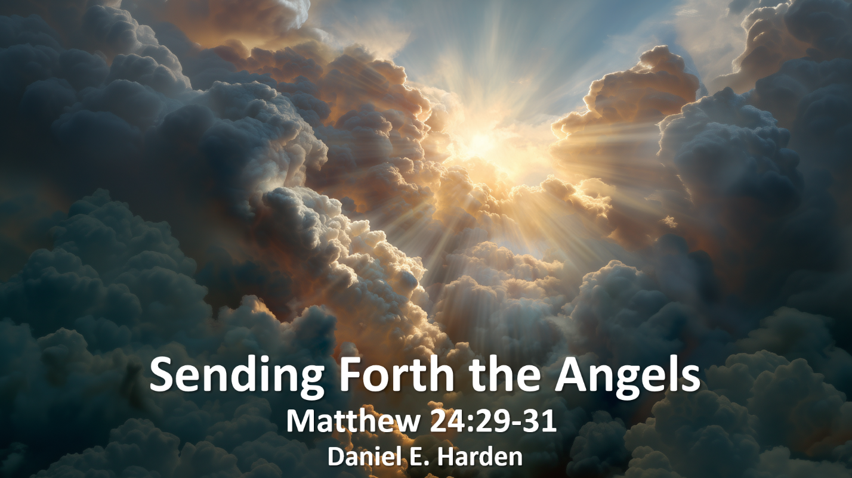
Sending Forth the Angels
Daniel E. Harden
Copyright © Daniel E. Harden (November 11, 2025)
All Rights Reserved

“Immediately after the tribulation of those days the sun will be darkened, and the moon will not give its light, and the stars will fall from heaven, and the powers of the heavens will be shaken. ³⁰ Then will appear in heaven the sign of the Son of Man, and then all the tribes of the earth will mourn, and they will see the Son of Man coming on the clouds of heaven with power and great glory. ³¹ And he will send out his angels with a loud trumpet call, and they will gather his elect from the four winds, from one end of heaven to the other.” (Matt. 24:29-31 ESV)

Many Christians today are still looking for this sign. But make no mistake, this prophetic utterance by Christ is connected with the fall of the temple (Matt. 24:2-3), since His statements are a direct answer to the question about the temple (Matt. 24:1). Furthermore, Christ follows this up with the clear statement that it would all happen in their generation (Matt. 24:34).
When one sees this clear language and accepts the Preterist recognition that Christ was not changing subjects, but referring to things that were about to befall the Temple and the Jews, then these time references come into better focus. But invariably, the topic arises as to what Christ meant in verse 31, and questions naturally arise. Even many who follow the Preterist thought on this passage tend to miss the full scope of what is being said by Christ, and in doing so, fail to recognize the full impact of this statement.
But we can get to the bottom of this simply by understanding several key points.
First, when Christ rose from the dead (as in 1 Cor. 15:3-7), it set off a series of events that would have cosmological significance. Before that time, any time a person died, they went to Hades (or Sheol, in Hebrew) – see, for example, Job 7:7-10; 17:13-16; Ps. 49:14-15; Eccl. 9:10; etc. We see this reflected in the parable of Lazarus and the rich man (Luke 16:19-31), among other places. It was the common understanding at the time of Christ, and it is also reflected in various places in Jewish literature before that time, such as in Enoch 21-22. But once in Hades, there was (up until that time) no escape (Job 7:9). The Jews held on to the promise and belief of the resurrection of the dead out of Hades, but did not know when that would take place. They only knew that it involved the Messiah.
There were, of course, various cases in the Bible of being raised from the dead back to physical life, but that didn’t break the power of death, because that was only a temporal resurrection. Those such as Lazarus (John 11:38-44), the daughter of Jairus (Mark 5:21-43; Luke 8:40-56), and the son of the widow of Nain (Luke 7:11-17) were raised by Christ, but only back to physical life. There is no indication that they didn’t still face Hades when they again died.
The victory over death only came as an eschatological event tied with the Parousia. Whether you see “death” as a reference to Hades or to the entity that ruled there, one thing is clear – the defeat of death was tied in with the return of Christ and the resurrection of the dead (1 Cor. 15:23-26).
Second, there was a war being waged in the spiritual realm between the time of the resurrection of Christ and the return of Christ. What 1 Cor. 15:23-26 describes is not just a defeat of death, but also the defeat of the enemies of Christ. We see such enemies referred to in various places, such as 1 Cor. 2:6-8; Eph. 2:2; Eph. 3:10; Eph. 6:12; Rev. 12:7-17.
Third, there was a change occurring at that time. There was a shift from the “present age” to the “age that is to come”. (Matt. 12:32; Eph. 1:21; etc.) Whenever we see a reference to ages, it is important to understand that this isn’t just some shift from the Jews and the Law to the Christians and faith. It has a much larger scope. A change in ages is a cosmological change. The result of this change is clear – God has complete control (1 Cor. 15:24; Rev. 11:15).
And this complete control meant that the dead were raised (1 Thes. 4:14-16) through the emptying of Hades (Rev. 20:11-15) and that those who died in Christ from that point forward would no longer face Hades, but would be “blessed” (Rev. 14:13), proceeding to judgment and Heaven.
When Christ came, the following occurred:
It begins with a loud trumpet, or last trumpet – Matt. 24:31; 1 Cor. 15:52; 1 Thes. 4:16; Rev. 11:15; etc
This heralded a series of events.
Whenever there is mention of the trumpet, the first thing to occur as a result of this trumpet blast is the resurrection of the dead. The trumpet call is followed immediately with the resurrection of the dead in 1 Cor. 15:52 and 1 Thes. 4:16, and this would be the initial stage of the gathering in Matt. 24:31 as well. Most commentaries actually agree with this point, noting that the events right after the trumpet call start with the resurrection of the dead. While this is sometimes stated as the raising of the saints (such as 1 Thes. 4:16), we know that it is a resurrection of all the dead, per Dan. 12:2-3; Acts 24:15; etc.
This is followed with the beginning of judgment, as depicted in Matt. 25:31-45. We find allusions to this in other places, such as 2 Tim. 4:1 and Rev. 11:18. Matt. 25:31-32 makes it clear that this judgment begins at this time (the Parousia), but Heb. 9:27 also makes it clear that every person who ever lived or will live must die and face this same judgment.
The result in the judgment for the dead, for each and every person, is stated in Matt. 25:46 – eternal life for the righteous, eternal punishment for the unrighteous (see also Rev. 14:11).
For the righteous, once judged, the saint proceeds on to Heaven.
So what happened as a result of the Parousia with regard to the afterlife? There was the immediate: resurrection of the dead (those who died before the “age to come”), but there was also the installation of the new, Hades-free process: judgment and final destination. The first people to undergo this judgment were those who were raised from Hades at that time, but it continues for every single person in turn. Eschatological passages refer to the immediate – the resurrection of the dead – as well as what that means for those who follow in turn when they die.
Angels were sent out in Matt. 24:31 because before that, all who died went to Hades. But beginning with the Parousia onward, when a person dies, no matter where in the world they are, they are collected by the angels and taken to the judgment seat. Thus Rev. 14:13, which specifically mentions the “blessing” that began with the Parousia and continues “from now on”.
In essence, there are three different “gatherings” – the gathering of the dead through resurrection to stand before the judgment seat; the gathering (συνάγω [sunagó]) of the living person when they subsequently die, also to stand before the judgment seat; and the ultimate or final gathering (ἐπισυναγωγή [episunagó]) of the saint after this judgment to the final destination in Heaven.
The Greek word ἐπισυναγωγή (episunagó), which appears in Matt. 24:31, is a form of the word sunago with the prefix ἐπί (epi-), which in this case acts as a strengthening of the gathering. The Greek word συνάγω [sunagó], as found in Matt. 25:32, can mean any type of gathering, but when the prefix ἐπί (epi-) is affixed, the intent is strengthened to indicate a specific or ultimate purpose or goal. In this manner, Matt. 25:32 indicates the general and initial gathering for judgment, while Matt. 24:31 goes beyond that to include the whole process including the ultimate goal, which for the saint (or sheep), is eternal life in Heaven.
Matt. 24:31 is a literal statement that actually encompasses all of this process, but also emphasizes the saints or chosen ones: the rising of the dead in Christ, followed by judgment, and proceeding to the final destination of heaven. The angels being sent to all the earth heralded the beginning of a new age in which every saint, as they died, no matter where on earth they happened to be, was gathered, judged, and then proceeded to heaven.
Since questions invariably arise, here are responses to some of them:
Who were the angels in Matt. 24:31?
Heavenly angels that were with Christ, such as in Matt. 25:31.
Who were the elect (or chosen ones)?
The reference to “elect” or “chosen ones” refers to all saints. First, with the return of Christ, to those who had already died and needed to be raised from Hades, but thereafter to any saint who died, which is why the angels were sent to all the earth.
Where were the elect gathered from and to?
From: those who were already dead, from Hades. Thereafter, the “from” is the entire earth, in that when a person dies, the angel gathers them directly.
To: first, the judgment seat, and then, to Heaven, since this is specifically about the elect. Take note, however, that just because this verse mentions the elect doesn’t mean that the unrighteous aren’t also gathered, to an extent. The rising of the dead in 1 Thes. 4:16 is given as “in Christ”, but that doesn’t mean that those who were not in Christ weren’t raised from Hades. They were. But the eschatological promises are often focused on the righteous, because it is the righteous who reap the benefits and obtain the ultimate heavenly gathering in Heaven. Notice that Matt. 25:31-32 uses very similar language to Matt. 24:30-31 – Christ’s coming, the angels, the gathering, etc., but Matt. 25:31-32 includes not just the elect, but all nations. Because this wasn’t something that would only affect the elect.
When did the gathering of Matt. 24:31 occur?
That question is actually too restrictive. Matt. 24:31 doesn’t say it was a one-time, limited gathering. It just says that the angels were sent out to gather the elect. So the initial wave was at the Parousia, with the resurrection of the dead. But this gathering was not a one-time event. It was only a beginning or initiation. Each saint today is gathered at death, as a direct result of the victory over the power of death and the sending forth of the angels. The resurrection of the dead itself wouldn’t have required that the angels be sent to all the earth.
How were they gathered?
Those already dead were gathered from Hades by means of the resurrection of the dead. Since that point in time, each saint who dies is taken immediately, no matter where on earth they are. It’s as simple as that. The first wave was at the resurrection of the dead, but after that, the angels continued to gather saints “from the four winds” as they died. This is reflected in Mark’s version of Christ’s statement:
And then he will send out the angels and gather his elect from the four winds, from the ends of the earth to the ends of heaven. (Mark 13:27 ESV)
The gathering is from both the spiritual realm and from earth. The dead were collected from Hades. And then the angels who are doing the gathering continue to gather from the ends of the earth – each in turn as they die. The angels were sent forth to inaugurate this process. This wasn’t possible while the “prince of the power of the air” (Eph. 2:2) still had control. It was only possible once the enemies were defeated and the power of death was annulled.
This is also why Paul was able to say with certainty that “we shall all be changed” – 1 Cor. 15:51 – whether they died before the Parousia as he was destined to do, or lived until the Parousia and beyond. All saints at that time were included in Paul’s statement, including Paul himself, even though he died prior to the Parousia. First, those saints who died before the Parousia were raised when Christ returned, judged, and then changed into their new spiritual body. Since then, each saint who dies is likewise judged and then changed into their new spiritual body. The “gathering” which began at the Parousia continues on even today.
Why were they gathered?
Why will we be gathered? Because the way to Heaven was opened once and for all for all saints. Again, Heb. 9:27. It is appointed for all men to die and face judgment. We are gathered when we die to face judgment, then to proceed from there. The why is extremely simple, regardless of whether one is talking about those raised from Hades at the Parousia, or about saints who have died after the Parousia. To face judgment. Understanding Heb. 9:27 is crucial in that it pertains to every person who has ever lived or will ever live. From that point, after having faced judgment, saints proceed to eternal life, the ultimate (final) gathering for saints.
To try to make the gathering of Matt. 24:31 as something different or special is problematic, because just as the resurrection was not just for the righteous but also for the unrighteous, the gathering was and is not just for the elect but for all people of all nations, Matt. 25:31-32. This gathering and separating in Matt. 25:31-32 began with His coming with His angels, but it continues on even today. It applies to all as they die in what was then referred to as the “age to come”, but what is now the current age. The gathering at the return of Christ with His angels in Matt. 25:31-32 must be linked with the gathering at the return of Christ with His angels in Matt. 24:31. The language is too similar to miss. Matt. 25:31-45 should be seen as an expanded explanation of Matt. 24:31.
There was also, at that time (the Parousia), a judgment for the living, but Rev. 11, Rev 14., Matt. 24, and many other places make it pretty clear that the living that were being judged were mostly just the apostate Jews and their cohorts. Judgment was temporal for the living, eternal for the dead. And whether or not one faced that temporal judgment while living, one still had to face the ultimate judgment before Christ once they died.
The coming of Christ marked a change in ages, which affected all aspects – physical, spiritual, cosmological. And as such, it also marked a significant change for the afterlife as well. As a saint today, we have the assurance that we won’t have to wait in Hades as the Old Testament patriarchs did, but will proceed directly to be with the Lord. Matt. 24:31 marked this beginning, this change in what happens at death. And each saint today still benefits from this change.
And I heard a voice from heaven saying, “Write this: Blessed are the dead who die in the Lord from now on.” “Blessed indeed,” says the Spirit, “that they may rest from their labors, for their deeds follow them!” (Rev. 14:13 ESV)

Special thanks to Robert E. Cruickshank, Jr., and Jordan Grant for their invaluable input.
The Jews held to a three-tiered cosmology, with Heaven above, the earth in the middle, and the underworld and Sheol beneath.
By the first century, there were a variety of beliefs on how this resurrection of the dead would take place, and whether or not it would include the physical body. See, for example, Chrys C. Caragounis, “Immortality of the Soul (Platon) and Bodily Resurrection (Paul) – Any Rapprochement?”, article in Fortunatae, Number 27, 2016, pgs 23-51, especially pg. 23: “Moreover there never was a ‘Jewish view’ of the resurrection. There were five/six views. The resurrection of the body was a minority view.” What is of note, however, is that all of these views were individual views, not corporate views.
HELPS Word-Studies describes ἐπισυναγωγή (episunagó) in this manner: “group together (collect), especially to accomplish the intended purpose of the gathering.”
In addition, this is exactly the same thing that 1 Thes. 4:17 refers to. Each saint since the return of Christ undergoes this process at death – being caught away into the spiritual realm (or “air”, just as it is also used in Eph. 2:2) to meet with the Lord and then be with Him forever.

