The Fourth Horse and the Flu? Pop-Prophecy’s Take on Revelation 6:8
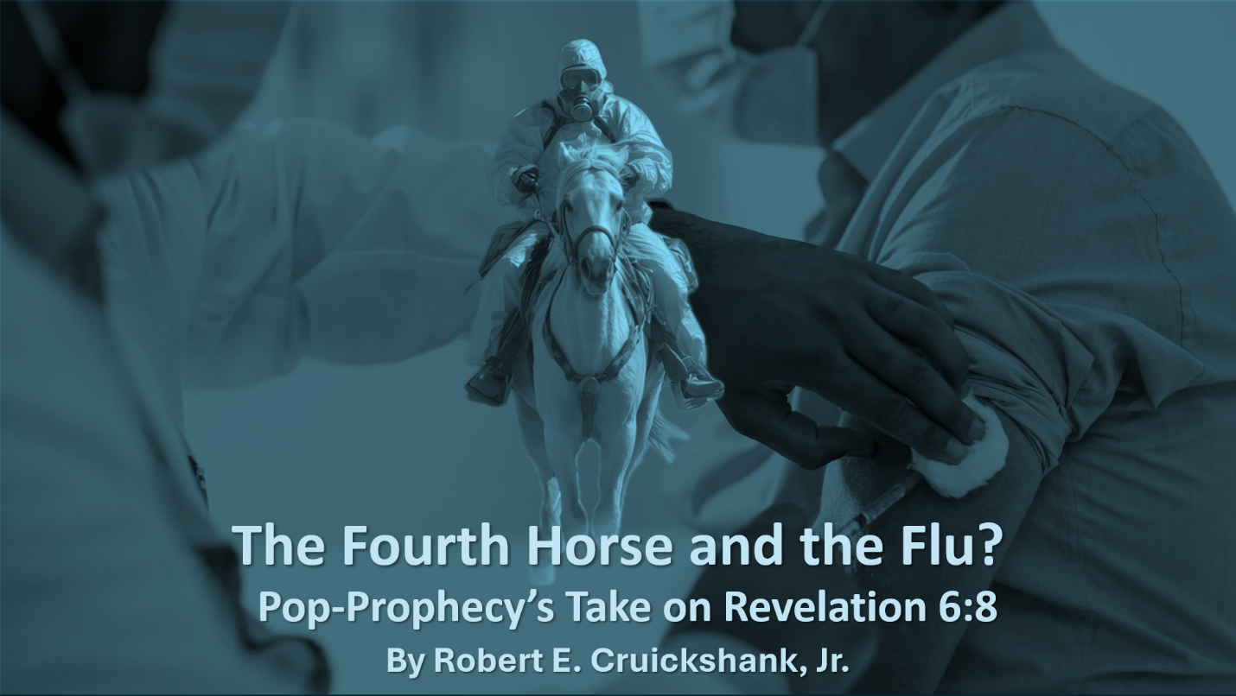
By Robert E. Cruickshank, Jr
Copyright © Robert E. Cruickshank, Jr. (October 20, 2025)
Danile E. Harden (Editor)
All Rights Reserved
“I looked, and behold, a pale horse; and the one who sat on it had the name Death, and Hades was following with him. Authority was given to them over a fourth of the earth, to kill with sword, and famine, and pestilence, and by the wild animals of the earth” (Rev. 6:8).
A horse is a horse, of course, of course, unless of course the horse is the famous fourth horse of the Apocalypse (Rev. 6:8). In that case, the horse is the flu virus - according to Derek and Sharon Gilbert.
In their Substack post, Rider on the Pale Horse: Prophecy and the flu, the Gilberts remind us to “remember that, in Matthew 24, the disciples asked Jesus to tell them when the ‘end of the age’ would occur.” In conjunction with the disciples’ question, “The time is now,” according to Gilbert & Gilbert.
How do the Gilberts know that “the time is now?” Well, it all started a “hundred years ago,” they tell us, when “the world was in the grip of a deadly wave of influenza.” The Gilberts go on to inform us: “When the pandemic at last ended, the final tally of dead equaled anywhere from 2–5 percent of the global population. We know it today as H1N1, dubbed by the mainstream media of the day as the Spanish Flu.”
In other words, the rider of the fourth horse is given authority to kill “over a fourth of the earth” (Rev. 6:8), and apparently this will be done through the spread of H1N1. So now we’re just waiting for that 2%-5% to reach 25% (1/4 of the total population), in fulfillment of the 6th chapter of Revelation – or so their narrative goes.
At the end of the day, the Gilberts’ take on Revelation 6:8 is another classic pop-prophecy mixture – of part Scripture, part speculation, and a heavy dose of sensation.
Misdiagnosing Prophecy
Filling out the rest of the pop-prophecy prescription, H1N1 is also the strain of influenza that causes not only the Spanish Flu but the Swine Flu, as well. Fittingly, other prophecy pundits have discovered that the “Swine Flu Vaccine” is “part of a New World Order/Global Elite/satanic plan of Eugenics AS WELL as a plan to get The Masses Chipped with THE MARK OF THE BEAST.”
So, this all connects. Well, not really, but I digress.
Anyway, back to the Gilberts and their post. Riding Revelation’s Pale Horse hard into the twenty-first century, they continue tracing H1N1 forward through history – all the way up to today.
“When the Pale Rider gallops across the globe,” they tell us, “he brings with him many types of pestilence, but influenza certainly captures the imagination, with its historic death toll numbers.” Something “is brewing out there,” they say, and “the rider on the pale horse is ready to carry it to the ends of the earth.”
In a nutshell, for the Gilberts, the answer to the disciples’ question about when the end of the age would occur is all about modern-day flu pandemics being prophetic signs of the end times. And this is supposedly represented by the sickly pale horse, in Revelation 6:8.
But considering John’s own prophetic prognosis, is this a correct diagnosis?
A Quick Reality Check and Revelation’s Context
Is John really talking about a flu outbreak that his original readers would never see take shape? What possible relevance would modern flu strains have for people receiving his letter 2000 years ago? More to the point, is John really ignoring the famine, death, and disease of their own time – just to focus on our time?
That would seem rather cold, crass, and careless – considering the concerns of his first-century audience.
Remember, John is writing to seven real, historical churches in first-century Asian Minor (Rev. 1:4). And the members of those churches were facing real historical challenges in their own day (Rev. 2:2-3, 9-10, 13, 20; 3:9-10, 17). Accordingly, John was writing to them about events that were “near” in their day (Rev. 1:3), and those events would “shortly take place” (Rev. 1:1). As such, twenty-first century flu epidemics don’t really fit the bill. On top of that, the first century definitely saw its own fill of death by sword, famine, pestilence, and wild beasts during the Roman-Jewish War.
The Pale Horse in History
With that said, the path of the Pale Horse parallels the path of history’s course in the first century. What John foresaw in his vision, Josephus documented with historical precision.
Again, Revelation 6:8 says that authority over one-fourth of the “earth” or “land” (γῆ <gē> - which can refer to a local area or nation) was given to the rider of the fourth horse. The rider had a name, and his name was Death. Accordingly, Josephus very much describes the war-torn city of first-century Jerusalem as a city of the dead. He says, “All the space round about and within the temple might be compared to a burying ground – so great was the number of the dead bodies therein” (Wars, 6.2.3).
Josephus’s comment here is in the context of those who had come to Jerusalem to celebrate the Passover and suddenly found themselves trapped inside the city – “shut up by an army” (Wars, 6.9.3). In his commentary on Revelation, J. Massyngberde Ford notes that “counting the pilgrims coming to Jerusalem, the population of that city could have been close to a quarter of that of the nation.” A quarter of the nation – hardly a coincidence, when seen against Revelation 6:8! Such a densely packed population, unexpectedly cut off and besieged, set the stage for the very calamities Revelation describes.
Alongside the sword, John says that famine and pestilence were also among the tragedies bringing death. As such, Josephus echoes Revelation 6:8 in speaking of both “famine” and “pestilence” during the time of the war. This shouldn’t surprise us at all since Jesus Himself said that “famines and pestilences” (Lk. 21:11) would be among the things to come upon that generation (Lk. 21:32). As Ford notes, famine and pestilence were in fact part and parcel among the tragedies that “did befall Palestine in the first century A.D., covering the period of the Baptist and afterward.”
And the fourth horse, bringing the famine and pestilence, was part and parcel of the fourth of the seven seals – the seals opened by The Lamb. When we look “back into Jewish literature written just before the Christian era, one discovers that lambs, rams, and lions, represent warlike leaders of the Jewish people who will be victorious over Israel's enemies.” Thus, the imagery of Jesus as The Lamb portrays Him as The Divine Warrior – executing retribution through human and natural forces.
This comports with God’s judgment comings in the Old Testament. In Habakkuk, for example, “God comes from Teman, the Holy One from Mount Paran” (Hab. 3:3). The judgment is upon Cushan and the land of Midian (Hab. 3:7). The prophet says, “Before Him goes pestilence, and plague comes after Him” (Hab. 3:5). Habakkuk adds the imagery of The Lord raging and riding in on His horses (Hab. 3:8).
All of this is reminiscent in Revelation 6:8, as death comes by sword, famine and plague through the Pale Horse and its rider, Death – the instrument of God’s judgment. As David Chilton comments, “…the fourth rider, with a much broader and more comprehensive commission, is named Death; and he is followed by Hades (the grave) – both having been set loose by the Son of Man, who unlocked them with His key (1:18).”
In addition to the sword, famine, and pestilence, death also came “by the wild beasts of the earth” (Rev. 6:8).
In this regard, Ken Gentry notes “the fate of the many Jews whom Rome captured and threw to the beasts for public torture.” Josephus in fact is replete with references to those thrown to “wild beasts” to be devoured by them. For example, in the aftermath of Titus’s forces storming and destroying the temple, Titus sent “a great number” of the surviving Jews “into the provinces; as a present to them: that they might be destroyed in their theatres, by the sword, and by the wild beasts” (Wars, 6.9.2).
John’s predictions match Josephus’s descriptions. What John saw in visions and portents, the people inside Jerusalem lived out in real events. The Pale Horse rode, not through a far-distant century, but through the streets of that ancient city and its surrounding environs.
From Prophecy to History
In short, the sad events that played out in history were foretold in John’s prophecy. And from our vantage point, they are in fact ancient history and not future prophecy or events playing out in modern-day epidemics. The fourth horseman’s death-dealing swords, famines, pestilences, and wild beasts match the horrors of the time. Revelation was not a coded forecast for our generation, but a prophetic letter aimed at the crisis confronting John’s own generation.
Let’s Not Retrofit Revelation
Put plainly, John wasn’t predicting future flu seasons or issuing warnings about today’s vaccines and microchips. He was writing to real people, in real time, about real events in their own time. Revelation 6:8 describes the devastating calamities experienced during the Roman-Jewish War – not a modern-day global health crisis. To pull the Pale Rider out of that historical context and saddle him in the twenty-first century is to retrofit Revelation and miss the point and purpose of John’s message to his original audience.
A prescription for the Pop-Prophecy Pandemic
The book of Revelation shouldn’t read like a symptom chart for our newsfeed. Rather, it should be read in light of its own historical context. That’s the prescription for the pop-prophecy pandemic. And it’s the grounding we need to keep from getting thrown off course by another prophecy pundit’s runaway horse. Let’s stop chasing prophetic speculation and plant our feet in the stirrups of sound interpretation. The last thing modern believers need is another booster shot filled with end-times sensation, and a healthy dose of history is the cure for this fixation.
There’s no waiting line for that shot – just open your Bible and read it in its own context…no horsing around!

Giants, Gods & Dragons - Rider on the Pale Horse: Prophecy and the flu https://bit.ly/4oqEAut
Swine Flu (H1N1): What Is It, Causes, Treatments & Prevention https://cle.clinic/4n8WxwB
Killer Swine Flu Vaccine And 666 Mark of The Beast All In One???... PLUS SWINE FLU VISION!!! Part 1 https://bit.ly/3WamKjt
See the marginal note for “Ashen horse” in the NASB.
γῆ: “Gloss: earth, world, country, region; land, ground, soil. Definition: earth, soil, Mt. 13:5; Mk. 4:8, et al.; the ground, surface of the earth, Mt. 10:29; Lk. 6:49, et al.; the land, as opposed to the sea or a lake, Lk. 5:11; Jn. 21:8, 9, 11; the earth, world, Mt. 5:18, 35, et al.; by synec. the inhabitants of the earth, Mt. 5:13; 6:10; 10:34; a land, region, tract, country, territory, Mt. 2:20; 14:34;by way of eminence, the chosen land, Mt. 5:5; 24:30; 27:45; Eph. 6:3; the inhabitants of a region or country, Mt. 10:15; 11:24, et al” γῆ | Free Online Greek Dictionary | billmounce.com https://bit.ly/3Jo6J6y
Josephus, Of the War — Book VI https://bit.ly/4nbstR2
Josephus, Of the War — Book VI https://bit.ly/4nbstR2
J. Massyngberde Ford, The Anchor Bible: Revelation – Introduction, Translation, and Commentary (New York, NY: Doubleday, 1975),108; for the technical details on calculating the number of pilgrims in Jerusalem for the Passover, see: Joachim Jeremias, Jerusalem in the Time of Jesus: An Investigation into Economic and Social Conditions during the New Testament Period (Philadelphia, PA: Fortress Press, 1969), 77-84.
Flavius Josephus, Wars of the Jews 4.353-4.388 https://bit.ly/47hkaNF , 4.361.
As Ian Boxall writes, “Luke’s version of Jesus’ eschatological discourse specifically refers to pestilence as one of the birth pangs along with famine (though using a different Greek word, λοιμός: Lk. 21:11)” (The Revelation of Saint John [Peabody, MA: Hendrickson Publishers, 2006]), 111.
Ford, The Anchor Bible: Revelation, 51.
Ford, The Anchor Bible: Revelation, 51.
David Chilton, The Days of Vengeance: An Exposition of the Book of Revelation (Tyler, TX: Dominion Press, 1987), 191.
Kenneth L. Gentry, Jr., Th. D., The Divorce of Israel: A Redemptive-Historical Interpretation of Revelation, Vol. I (Acworth, GA and Vallecito, CA: Tolle Press and the Chalcedon Foundation, 2024), 632.
E.g., Wars, 6.9.2; 7.2.1; 7.3.1; 7.8.7
Josephus, Wars, 6.4.5
Josephus, Of the War — Book VI https://bit.ly/4nbstR2 ; emphasis added.

